ASSIGENMENT -3

NAME : ANJALI BHAGYWANT

============Assigenment for deployement Jenkins war by using scp commnd by two remote server………

**THIS IS OUR 2 INSTANCE :**

**1 )JENKIN MASTER:**

**2)TOMCAT SERVER**:

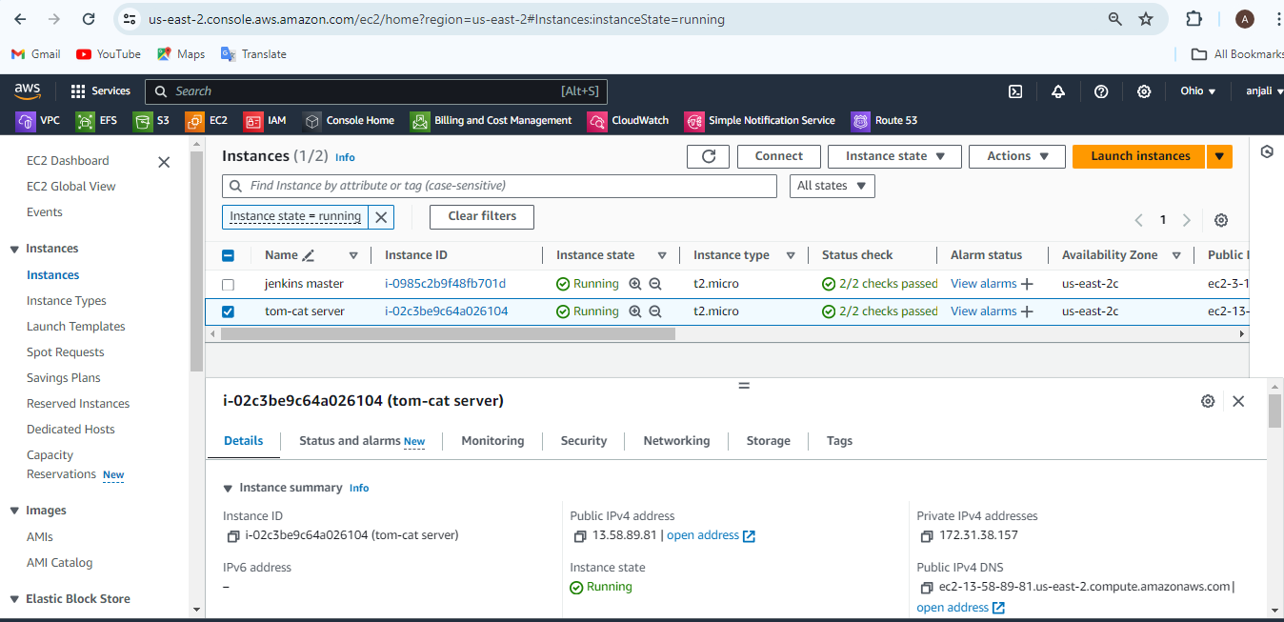

==================================================================================**JENKINS MASTER CONFIGRATIONS:**

[root@ip-172-31-43-130 jenkins]# cd /mnt/

[root@ip-172-31-43-130 mnt]# mkdir project

[root@ip-172-31-43-130 mnt]# cd project/

[root@ip-172-31-43-130 project]# wget <https://get.jenkins.io/war-stable/latest/jenkins.war>

[root@ip-172-31-43-130 ~]# cd /mnt/project/

[root@ip-172-31-43-130 project]# scp -i OHIO-KEY.pem jenkins.war [ec2-user@172.31.38.157:/mnt/server/apache-tomcat-9.0.89/webapps](mailto:ec2-user@172.31.38.157:/mnt/server/apache-tomcat-9.0.89/webapps)

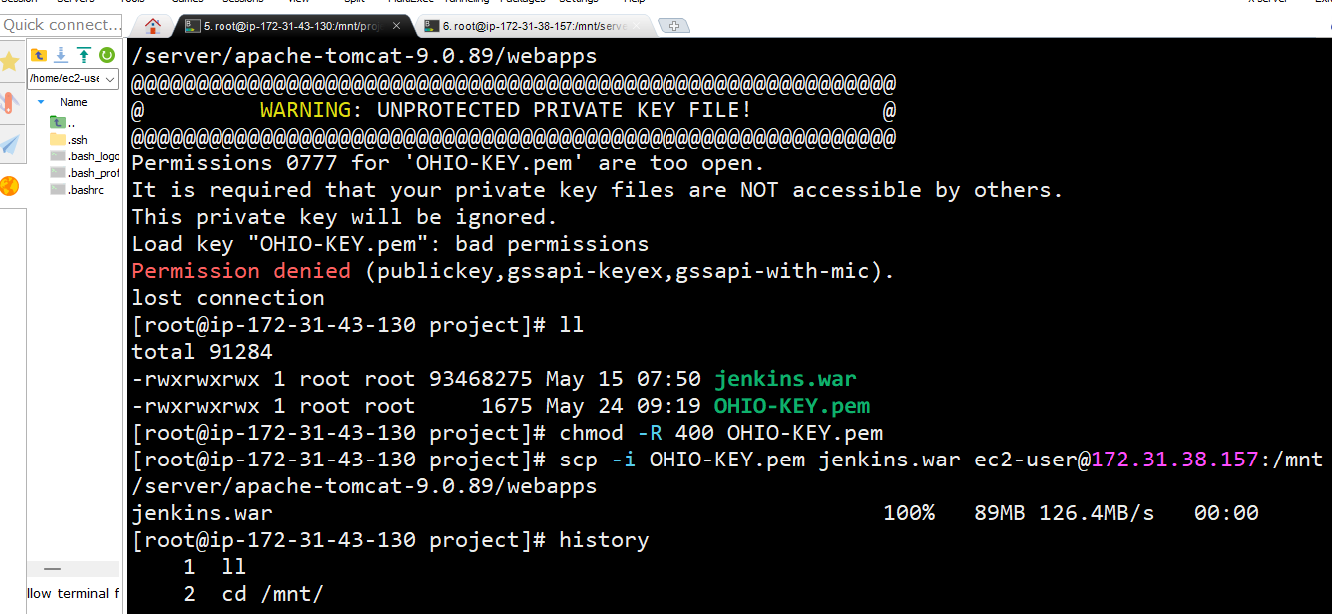

=================================================================================================================================**TOMCAT SERVER CONFIGERATIONS:**

[ec2-user@ip-172-31-38-157 ~]$ sudo su –

#yum install java -y

[root@ip-172-31-38-157 ~]# cd /mnt

[root@ip-172-31-38-157 mnt]# mkdir server

[root@ip-172-31-38-157 server]# wget <https://dlcdn.apache.org/tomcat/tomcat-9/v9.0.89/bin/apache-tomcat-9.0.89.zip> (unzip it..)

[root@ip-172-31-38-157 apache-tomcat-9.0.89]# cd bin/

[root@ip-172-31-38-157 bin]# ./startup.sh

[root@ip-172-31-38-157 apache-tomcat-9.0.89]# cd webapps/

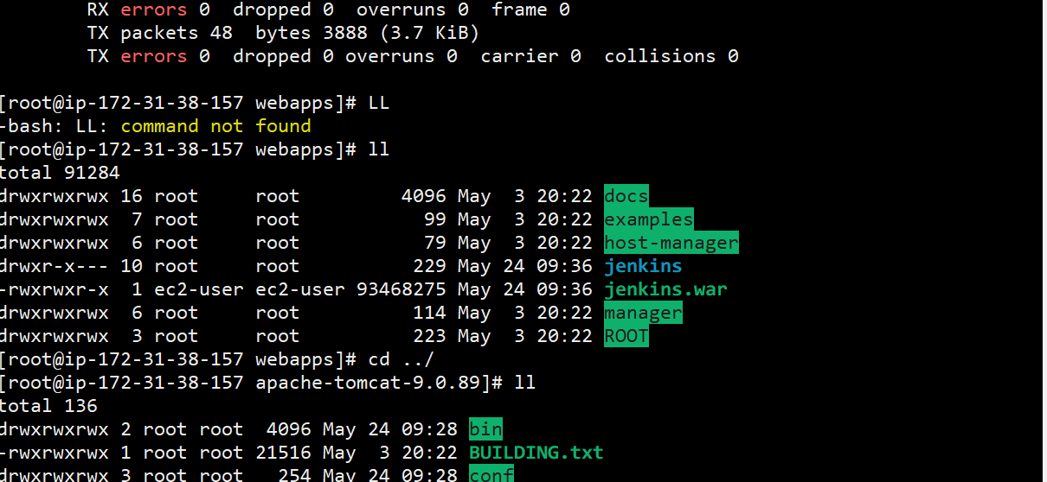

[root@ip-172-31-38-157 bin]# ./shutdown.sh

[root@ip-172-31-38-157 bin]# ./startup.sh

**Here we deploye jenkin war on tomcat ……………**

.